**Probability Addition and Multiplication Rule**

#### **1. Addition Rule (OR Probability)**

The **addition rule** is used when calculating the probability of **either** one event happening **or** another.

✅ **Formula:**

* If **events are mutually exclusive** (cannot happen together):



* If **events are not mutually exclusive** (can happen together):



📌 **Example 1 (Mutually Exclusive Events)** What is the probability of rolling a **1 or 2** on a fair die?

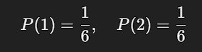

Since rolling a 1 and 2 at the same time is impossible,

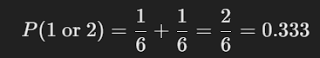

📌 **Example 2 (Not Mutually Exclusive Events)** What is the probability of drawing a **red card or a king** from a deck of 52 playing cards?

* **P(Red Card) =** 26\52 (26 red cards)
* **P(King) =** 4\52​ (4 kings)
* **P(Red King) =** 2\52​ (2 red kings)

Using the formula:

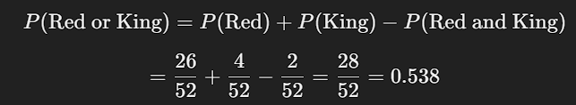

#### **2. Multiplication Rule (AND Probability)**

The **multiplication rule** is used when calculating the probability of **two events happening together**.

✅ **Formula:**

* If **events are independent** (one does not affect the other):



* If **events are dependent** (one affects the other):



where P(B∣A) is the probability of B given that A has already happened.

📌 **Example 1 (Independent Events)** What is the probability of flipping **two heads in a row** on a fair coin?

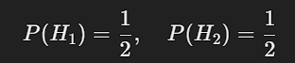

Since these are independent,



📌 **Example 2 (Dependent Events)** What is the probability of drawing **two aces in a row** from a deck of 52 cards?

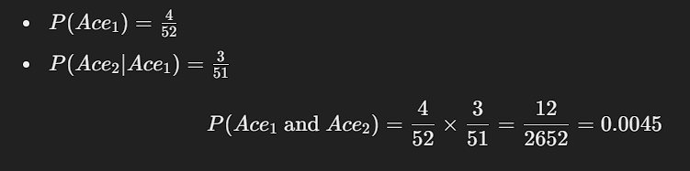

### **Python Example (Multiplication Rule)**

import random

# Simulate flipping two heads in a row (independent events)

trials = 10000

success = sum(1 for _ in range(trials) if random.choice(["H", "T"]) == "H" and random.choice(["H", "T"]) == "H")

# Estimate probability

print("Estimated Probability of flipping two heads:", success / trials)

### **Complementary Events in Probability**

A complementary event is the event that represents all outcomes not included in a given event.

✅ Formula for Complementary Probability:



where:

* P(A) is the probability of event A occurring.
* P(A′) is the probability of event A not occurring (complement of A).

### Examples

📌 Example 1: Rolling a Die  
 Let event A be rolling a 6 on a fair die.

P(A)=1\6

The probability of not rolling a 6 (complement of A) is:

P(A′)=1−P(A)=1−1\6=5\6=0.833

### **Python Example**

You can simulate complementary probability using Python:

import random

# Probability of rain (given)

p_rain = 0.3

# Compute complementary probability (no rain)

p_no_rain = 1 - p_rain

print("Probability of no rain:", p_no_rain)